*In the United States, institutions of higher learning produce teaching. They also produce research. And in addition, for reasons we will be exploring, they produce athletic entertainment (huh!?). College sports programs are a major source of revenue for universities who sell tickets, merchandise and TV rights. They are also a major source of university costs, for example, stadium construction costs, labor costs of stadium workers and athletic staff.*

*Why are educational institutions in the sports entertainment business? In this assignment, you will study this question through a propensity score design. In particular, you will be looking at cross section data about 100 top colleges in the year 2017. In 2017, 50 of these colleges were ranked as having a "Top Basketball Program." A committee selected which programs would get this designation. Being "ranked" guarantees some visibility in the media. These "ranked" programs were in the annual public and media conversation about who would win the annual tournament.*

*Your challenge in this assignment is to estimate the causal effect of being ranked on alumni donations the following year. Note: Even if there is a positive effect on alumni donations, this does not entirely justify why a university would be in the sports business. That question is somewhat normative. However, it may provide some evidence of the forces at play inside these institutions.*

#### Balance Tables

| \begin{tabular}{l*{6}{c}}  & Control& Treatment& Difference \\ \hline Academic.Quality & 0.515& 0.466& 0.049 \\ Athletic.Quality & 0.424& 0.551& -0.127** \\ Near.Big.Market & 0.360& 0.700& -0.340***\\ \end{tabular} |
| --- |

The control and treatment group have significant differences in athletic quality and location relative to a large metropolitan area.

***First,*** *please comment on the following issue. As you know, propensity score methods are more credible when we (the researchers) are able to use all variables that the agents who assign treatment scan use in their assignments.* ***Comment on how this applies to this setting.***

This applies to this setting because the only observed covariates in the dataset are academic quality, athletic quality and proximity to a metropolitan area. There are probably many unobserved variables that went into the 2017 college basketball rankings *and* affect alumni donations. Obviously, historical basketball performance would be one that may not be fully captured in athletic quality. Others could include successful basketball alumni, program funding, social impact of the program and more.

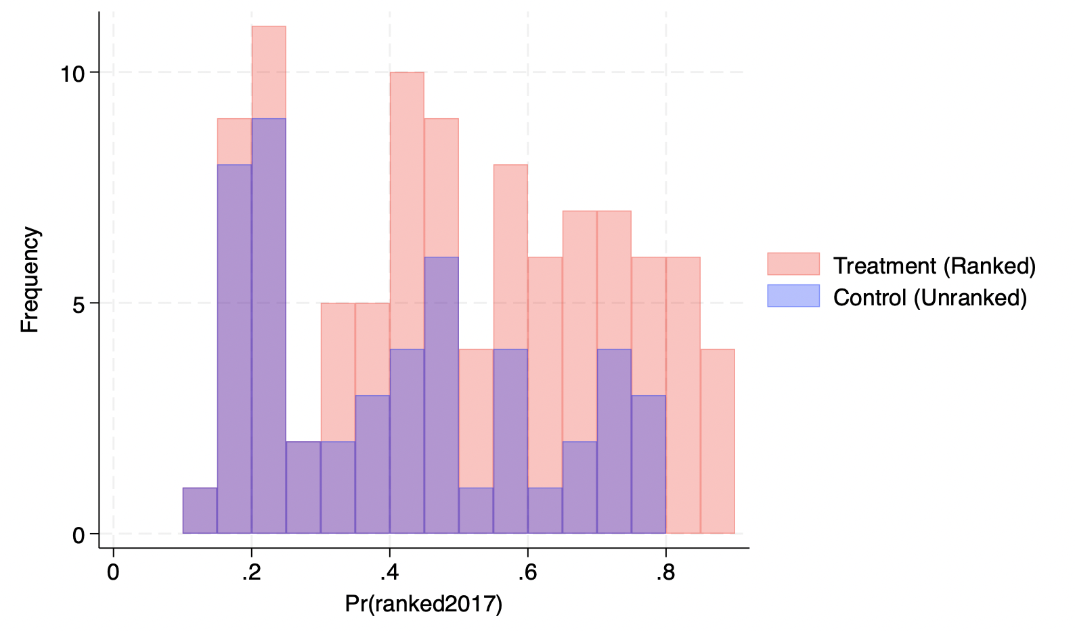

| ------------------------------------  (1)   Donations  ------------------------------------ Ranked in 2017 500.502***  (0.264)  Academic Quality 101.395***  (1.726)  Athletic Quality 47.188***  (3.636)  Near Big Market 997.328***  (2.994)  Block=0 0.000   (.)  Block=1 -0.242   (0.859)  Block=2 -0.223   (0.978)  Block=3 0.709   (1.144)  Block=4 0.758   (1.288)  Block=5 0.622   (1.467)  Block=6 0.583   (1.962)  Block=7 0.993   (2.201)  Block=8 0.674   (2.465)  Block=9 1.474   (2.672)  Block=10 1.219   (2.804)  Block=11 2.388   (3.023)  Block=12 2.282   (3.179)  Block=13 2.172   (3.436)  Block=14 2.471   (3.678)  Block=15 1.805   (3.796)  Block=16 2.626   (4.015)  Block=17 2.349   (4.246)  Block=18 4.181   (4.555)  Block=19 3.491   (4.808)  Block=20 3.455   (4.974)  Block=21 3.846   (5.347)  Block=22 4.334   (5.641)  Block=23 4.275   (6.091)  Block=24 4.276   (6.536)  Block=25 5.262   (6.773)  Constant -0.137   (0.933)  ------------------------------------ Observations 100  ------------------------------------ Standard errors in parentheses * p<0.10, ** p<0.05, *** p<0.01 |
| --- |

The results show that being ranked in 2017 as having a “Top Basketball Program” is associated with a $500,502 increase in alumni donations in 2018, holding all other covariates and block-fixed effects constant. The result has high statistical significance (p < 0.01), meaning there is strong evidence that being ranked has a positive causal effect on alumni donations.